**Lampiran 1.Gambar Alamanda Hall Dan Flamboyan Hall**

Alamanda Hall

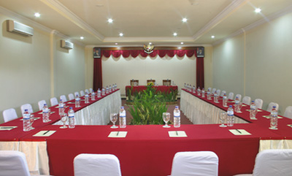

Flamboyan Hall

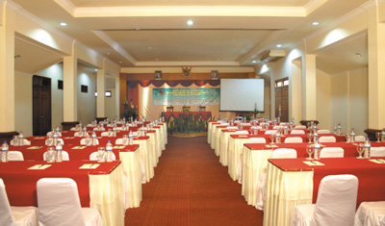

**Lampiran 2.Gambar Flamboyant Restoran Dan Lotus Café**

Flamboyan Restaurant

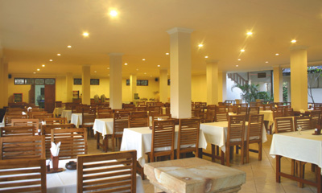

Lotus Café

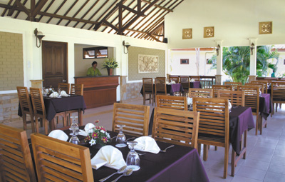

**Lampiran 3.Gambar Lobby Dan Pool**

Lobby Lombok Garden Hotel

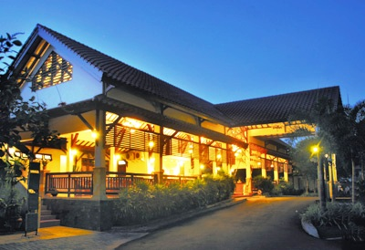

Pool

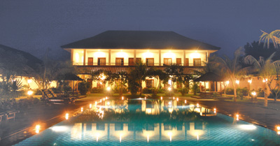

**Lampiran 4.Gambar Room Hotel Lombok Garden**

Superior double

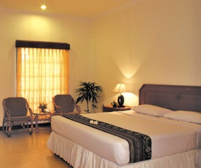

Superior room

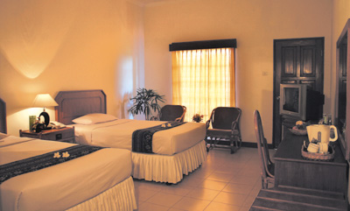

Superior room pagi

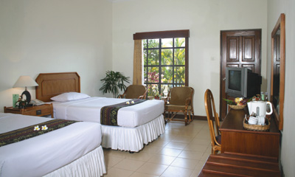

**Lampiran 5 : Alat-alat Roomboy**

|  |  |  |
| --- | --- | --- |
| <http://2.bp.blogspot.com/-BtEgYSIZmy8/UwR1lBdUBSI/AAAAAAAAAIQ/ua8_ibV4rHo/s1600/Window+wipper.jpg> | <http://4.bp.blogspot.com/-tposxF0Zuw8/UwR1NXnyJmI/AAAAAAAAAII/tnFr8c_jlug/s1600/Window+washer.jpg> | <http://3.bp.blogspot.com/-LnEmG_IvNkg/UwR804aa42I/AAAAAAAAAKg/1tKv2uOGChc/s1600/Floor+Squeeqee.jpg> |
| <http://1.bp.blogspot.com/-FI0hW4UF6wU/UwR0NlOHGsI/AAAAAAAAAH4/X61ZLLBuIC8/s1600/caution+danger+1.jpg> | <http://3.bp.blogspot.com/-dHQsenZC0g4/UwRxzUzjNZI/AAAAAAAAAHY/NK189iD7NPE/s1600/Interior+cloth.jpg> | <http://4.bp.blogspot.com/-utFA_DteXfU/UwR9npagzOI/AAAAAAAAAKw/FuWP0nG5mF8/s1600/Dust+pan+and+brush.jpg> |
| <http://1.bp.blogspot.com/-2Cag-lSCd5o/UwRzRfHpNKI/AAAAAAAAAHo/AiEOdVUEgkM/s1600/Pad+Scourer.jpg> | <http://4.bp.blogspot.com/-lKZkwBWdBws/UwR6ssS5GMI/AAAAAAAAAJ4/GTo524mjj1s/s1600/Brush+and+long+sticc.jpg> | <http://1.bp.blogspot.com/-f8tBeemn-44/UwR01qJFHaI/AAAAAAAAAIA/kcr0iGYPmZo/s1600/Telescopic+stic.jpg> |
| <http://2.bp.blogspot.com/-TzXMA_VQY_c/UwR3yzjfC3I/AAAAAAAAAJA/jTchCjbJflo/s1600/Floor+Maintenance+Machine.jpg> | G:\nok\4993755_20121213031446.JPG | <http://1.bp.blogspot.com/-VBxalBQOHNU/UwR8aTIWhDI/AAAAAAAAAKY/i-W65ejcGRA/s1600/Lobby+Duster.jpg> |
| <http://3.bp.blogspot.com/-N-zyYOajMF4/UwR7aHI8vUI/AAAAAAAAAKI/T0Bkxb0zoXA/s1600/Toilet+bowl+brush.jpg> | <http://2.bp.blogspot.com/-8yCUNF7bpsY/UwRwp42Y7kI/AAAAAAAAAHM/vFODtHFphQo/s1600/countainer+bin+1.jpg> | <http://1.bp.blogspot.com/-JBNmUrXHaWI/UwR5kBNhGOI/AAAAAAAAAJo/GTYLp_zFfh8/s1600/Hand+brush.jpg> |
| <http://1.bp.blogspot.com/-maTVXk3Sg6Y/UwR7EJOLPfI/AAAAAAAAAKA/D9zTLAHtblc/s1600/Pail.jpg> | <http://4.bp.blogspot.com/--E2f_dCB6Ug/UwR9NRVDuaI/AAAAAAAAAKo/cBYX84VAu98/s1600/Hand+Glove.jpg> | <http://1.bp.blogspot.com/-hvUuSU1HqiU/UwR2CyAwakI/AAAAAAAAAIc/IaBlLIIpfsE/s1600/Bottle+sprayer.jpg> |

**Lampiran 6 : Denah Lombok Garden**

**