INTERNATIONAL RESEARCH SYMPOSIUM ON SUSTAINABLE TOURISM DEVELOPMENT August 29 – 31, 2014

Topic code 21-01

STRENGTHENING HEALTH TOURISM IN LOMBOK: DEVELOPMENT OF MEDICAL TOURISM CURRICULUM IN FACULTY OF MEDICINE MATARAM UNIVERSITY

Eustachius Hagni Wardoyo, Hamsu Kadriyan, Dewi Suryani, Dian Puspita Sari

Faculty of Medicine Mataram University

ABSTRACT

Background: The need of strengthening health tourism in Lombok is a challenge of many sectors including the Faculty of Medicine Mataram University (FMMU). In order to educate tourism physicians, FMMU confers challenge to develop medical tourism curriculum. Objective: To describe the development of medical tourism curriculum to under graduate students .Method: The study is a descriptive study. The medical tourism subject is divided in two majors: marine medicine and marine emergencies. Result: Major in marine medicine they are: health tourism, the harmful animal of the shore, medical clearance for diving and seafarer, SOLAS and passenger quarantine. Major in marine emergencies as follow: diving physiology, near drowning, decompression sickness, air-gas embolism and hyperbaric oxygen therapy. The curriculum is distributed in learning activities: tutorial, lecture, field visit, and medical skills. Student’s assessment: plenary, written test, field visit report, medical skills test. The curriculum planned to be implemented on five blocks, they are: homeostasis, family medicine, emergency, sense and respiration. Conclusion: The medical tourism curriculum is developed at the FMMU

Keywords: medical tourism, health tourism, medical tourism curriculum

1. INTRODUCTION

Today people around the globe is seeking destination to the most ‘interesting places’ in the world away from their daily routines. The term interesting places refer to tourism destination. The main theme of destination may be similar between places to places (i.e. marine and shore tourism), but the marketing strategies could be different. Facilities provided (i.e. medical tourism) is one of the key of marketing strategies.

Lombok as one of famous tourism destination in Indonesia has diverse theme: from mountaineering, marine and shore tourisms, handcraft and cultural tourism to culinary tourism. These themes drive the need of facilities, including tourist medical services that corresponds to tourism themes.1

The health risk of tourism activities is need to be measured and studied. And between those themes, the marine and shore tourism seems to have a prominent health risk that should be covered in medical tourisms in the island.

Meanwhile, Indonesian medical education recently had implement competence-based curriculum. Which reflect the increasing needs of acquisition of basic scientific knowledge and practical skills in well-defined subject areas.2,3,4

FMMU as one of leading medical education institution in the island has an obligation to train physician with medical tourism competencies.

This paper is describe the development of medical tourism curriculum to under graduate students

ISBN: 978-979-8911-83-5

Eustachius Hagni Wardoyo et al Topic Code: 21-01

2. METHODS

2.1. Medical tourism curriculum construction

This is a descriptive study. Medical tourism curriculum was developed with in the following steps (modified from Donnelly dan Fitzmaurice, 2005)5 : 1) preparation; 2) construction; 3) construct methods of student’s assessment.

The AIPKI (Asosiasi Institusi Pendidikan Kedokteran Indonesia / Indonesian Association of Medical Educational Institutions) encourage every medical schools in Indonesia to develop its own local content curriculum as much as 20%.6 In order to strengthening health tourism in Lombok, therefore FMMU develop blueprint curriculum; which medical tourism outlined as local content curriculum.7 The medical tourism subject covered by the blueprint is divided in two majors: marine medicine and marine emergencies. This is where the medical tourism curriculum construction is began.

RESULT

The subject included in the curricula is divided in two majors (figure 1). Each major represents characteristic how urge tourism medical services should be delivered.8-12

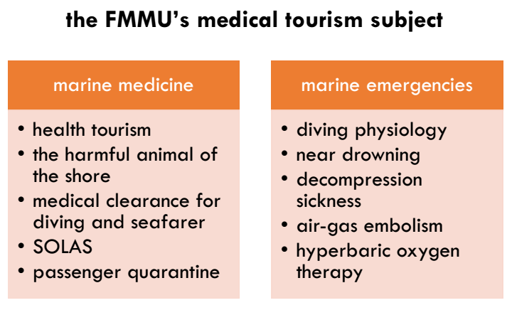

Fig. 1. The FMMU’s medical tourism subject

Development process of medical tourism curriculum was constructed through three stages (modified from Donnelly and Fitzmaurice, 2005)5 as follows: preparation, construction and evaluation (table 1).

|  |  |
| --- | --- |
| Stages | Activities |
| Preparation | Retrieval of lecturer needs, student needs, and institution needs |
| Construction | Constructive alignment: define learning objectives, learning activities and assessment |
| Evaluation* | Expert peer review, student and lecturer evaluation |

Table 1. Development process of medical tourism curriculum

*)evaluation stage is not covered in the study

2.2. Preparation stage

This stage aimed to retrieve level of competency each subject and the way how student to achieve it. Lecturer were asked to fill level of knowledge and level of competency suggestion in a short questionnaire. Student needs were unable to assess due to new concept of knowledge that they never receive. Institution need is positioned in local content of curriculum in Blue Print Curriculum (2012). Overall preparation is synthetize and analyzed. The preparation stage is finalized as level of competency (table 2).



67

INTERNATIONAL RESEARCH SYMPOSIUM ON SUSTAINABLE TOURISM DEVELOPMENT August 29 – 31, 2014

Table 2. Level of competency

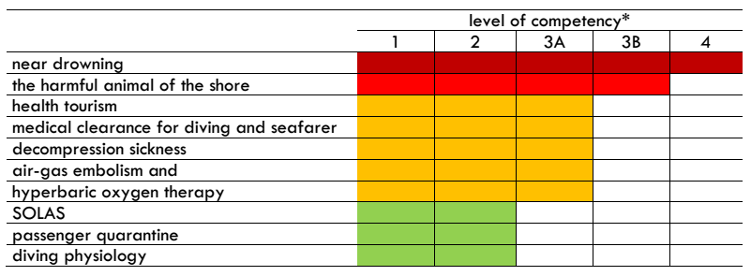

*level of competency classification by the the Medical Council of Indonesia (2012)

2.3. Learning activities and methods of assessment

Table 3. Learning activities and methods of assessment



The acquisition of competency must be achieve with several learning strategies/ activities. Table 3 proposed learning strategies and methods of assessment of each subject. This learning activities still can be argued and revised later after implementation through internal and external evaluation of curriculum.

2.4. Distribution of subjects into designated block

Medical tourism curriculum is implemented in existing blocks (undergraduate level, see table 4 below). Reason for not to make a new block are: 1) all subjects are related to or act as subtheme of existing blocks; 2) existing blocks are deployed by different groups of lecturer, which make the curriculum easily spread to lecturer and student.



3. DISCUSSION

In the changing era of tourism and the needs of tourist medical services, it takes further research in best practices of medical tourism. In medical terminology, medical tourism cover broad range of occupation medicine. Medical faculty has moral obligation to develop medical tourism curriculum specified to local condition.

Developing a new curriculum in FMMU is challenging. An example challenges is plan implementation and then the evaluation, allowing the curriculum revision. Furthermore, documenting the relationships between curriculum development and learner’s competencies, or furthermore local health tourism outcome represents one of the biggest challenges and greatest opportunities in curriculum development.4,13

The major of marine medicine and marine emergency is not narrowing the wide subject of health tourism, but from the local tourism potency’s perspective those two major represents sufficient part of health tourism in Lombok. It is unbearable to cover all subject of health tourism.

4. CONCLUSION

The medical tourism curriculum is successfully developed at the FMMU

REFERENCES

AIPKI. 2012. Standar Pendidikan Profesi Dokter Indonesia.

http://www.hpeq.dikti.go.id/v2/images/Produk/19.1-Draf-Standar-Pendidikan-Kedokteran-16mei- 2012.pdf [Accessed 24 April 2013]

Anonim, 2012, Blueprint kurikulum muatan local FK Universitas Mataram. Mataram 2012. Collins J., 2006; Medical Education Research: Challenges and Opportunities. Radiology 2006;

240(3):639–647

Donnelly, R & Fitzmaurice, M. 2005. Designing Modules For Learning [Online]. Dublin: All Ireland Society for Higher education. http://www.aishe.org/readings/2005-1/index.html [Accessed 24 April 2013]

KK Jain (ed). Textbook of Hyperbaric Medicine. 2nd edition. Hogrefe & Huber Publishers. Seattle. 1996 Mahdi, Dina., 2009, Pidato Ilmiah Kedokteran Kelautan. Kolegium Kedokteran Kelautan. Jakarta.

69

INTERNATIONAL RESEARCH SYMPOSIUM ON SUSTAINABLE TOURISM DEVELOPMENT August 29 – 31, 2014

Mathieu, Daniel (editor)., 2006, Handbook of Hyperbaric Medicine. Springer. Netherland.

Near JA, TR Bosin and JB Watkins III. 2003, Implementation of Competency-based Curriculum in Medical Pharmacology. Indiana University School of Medicine. 2003. http://bl-msci- near.ads.iu.edu/nearlab/teaching%20pharmacology%202002%20poster.ppt [Accessed 21st Nov 2010]

Pemerintah Propinsi Nusa Tenggara Barat. 2013, Kondisi Geografis Propinsi Nusa Tenggara Barat. http://www.ntbprov.go.id/tentang_geografis.php diakses 2 Juni 2013

PKHI. 2000, Pengantar Ilmu Kesehatan Penyelaman. Perhimpunan Kesehatan Hiperbarik Indonesia. Jakarta. 2000

Wardoyo EH, BM Syahrizal, D Purnaning, IAE Widiastuti, A Ekawanti, and MF Wajdi. 2010, Introduction of Student Oral Case Analysis (SOCA) to assess student’s performance in pre- clinical setting in Faculty of Medicine, Mataram University, Cermin Dunia Kedokteran, Agust 2010; 37(6): 434-436

Wardoyo EH., 2013 Implementation of Nutrition Curriculum to Undergraduate Students Faculty of Medicine Mataram University. Jurnal Kedokteran Unram. Ed 3, Vol 2, Juni 2013

Wardoyo EH, Sidik S, Riyono A, Pranata AJ. 2012, Buku Panduan Bagi Petugas Hiperbarik. PT HMS Jakarta 2012